**Magnetic Force, Fields and Materials**

A magnet is a material that can attract other materials with magnetic properties. These substances are called **ferromagnetic**. Nickel, cobalt and iron and any alloy containing these are behave in the same way. You can induce them to become magnetized by placing them in a magnetic field.

A **permanent magnet** is an object made from a material that is *magnetized* and creates its own persistent magnetic field. An everyday example is a refrigerator magnet used to hold notes on a refrigerator door.

An **electromagnet** is made from a coil of wire which acts as a magnet when an electric current passes through it, but stops being a magnet when the current stops. Often an electromagnet is wrapped around a core of ferromagnetic material like steel, which enhances the magnetic field produced by the coil.

Magnets have areas of concentrated magnetic force on the poles. The N-pole is called the north seeking pole and the S-pole is called the south seeking pole. They will seeking the North & South pole of the Earth.

Law of Magnetic Poles:

Opposite poles attract and similar poles repel.

N-pole will attract an S-pole

N-pole will repel an N-pole

S-pole will attract an N-pole

S-pole will repel an S-pole

Magnetic Field of Force: the space around a magnet in which magnetic forces are exerted.

We can find the magnetic field by using iron filings or small compasses around a magnet.

Magnetic fields are represented by a series of lines around a magnet, showing the path the N-pole of a small test compass would take if it were allowed to move freely in the direction of the magnetic force.

|  |  |
| --- | --- |
| http://image.tutorvista.com/content/magnetic-effects-electric-current/bar-magnet-magnetic-field.jpeg | http://physicslearning.colorado.edu/PiraHome/ResourceCD/ResourceImages/PhysicsDrawings/Magnetic_Field_Lines.gif |

The characteristics of magnetic field lines are summarized below.

1. The spacing of the lines indicates the relative strength of the force. The closer together the lines are, the greater the force.
2. Outside a magnet, the lines are concentrated at the poles. They are closest within the magnet itself.
3. By convention, the lines proceed from S to N inside a magnet and from N to S outside a magnet, forming closed loops. (A plotting compass indicates these directions.)
4. The lines do not cross one another.

Note that the magnetic field around a bar magnet is three-dimensional in nature; it does not exist just in the horizontal plane.

**Magnetic Materials**

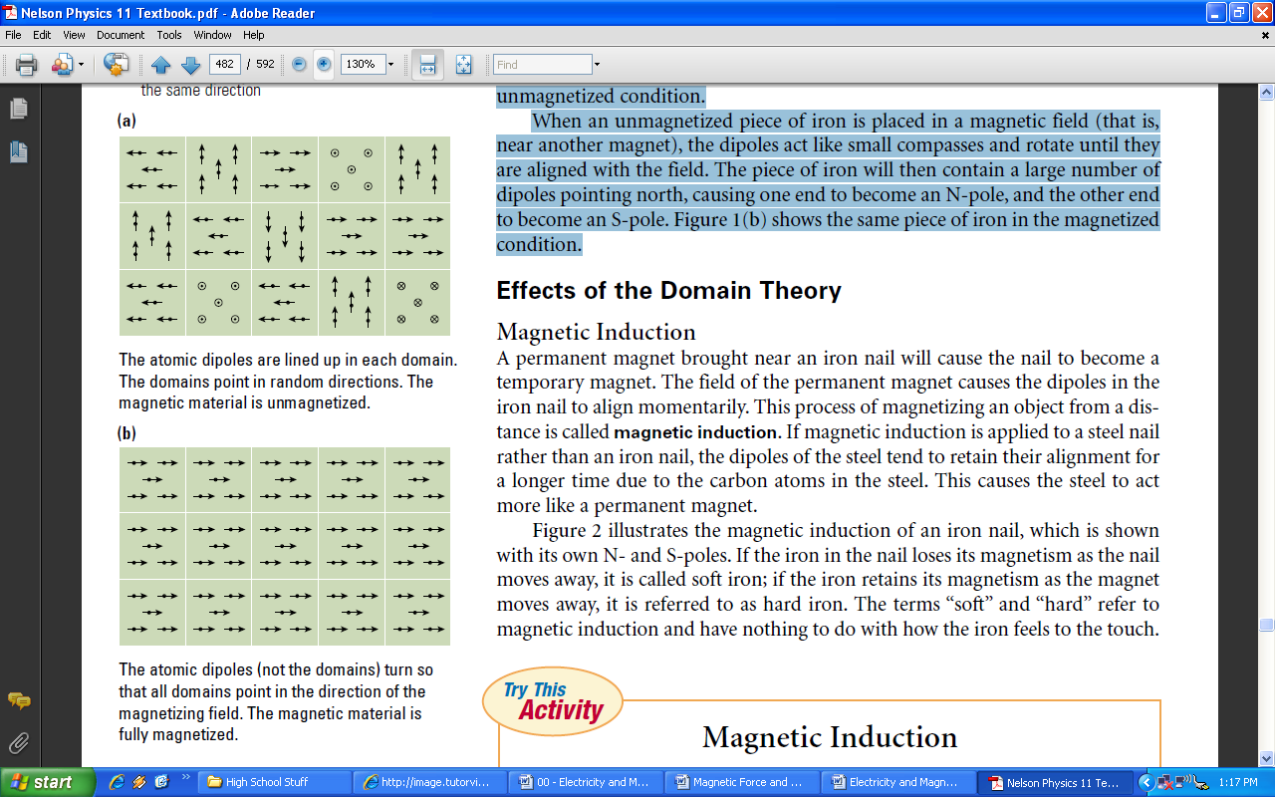**Domain Theory of Magnetism**

The atoms of ferromagnetic substances can be thought of as tiny magnets with N-poles and S-poles. These atomic magnets, or **dipoles**, interact with the nearest neighbouring dipoles and a group of them line up with their magnetic axes in the same direction to form a **magnetic domain**. An unmagnetized piece of iron contains millions of these domains, but they are pointing in random directions so that the piece of iron, as a whole, is not magnetized. **Figure 1(a)** represents this unmagnetized condition.

When an unmagnetized piece of iron is placed in a magnetic field (that is, near another magnet), the dipoles act like small compasses and rotate until they are aligned with the field. The piece of iron will then contain a large number of dipoles pointing north, causing one end to become an N-pole, and the other end to become an S-pole. **Figure 1(b)** shows the same piece of iron in the magnetized condition.

**Magnetic Induction**

A permanent magnet brought near an iron nail will cause the nail to become a temporary magnet. The field of the permanent magnet causes the dipoles in the iron nail to align momentarily. This process of magnetizing an object from a distance is called **magnetic induction**. If magnetic induction is applied to a steel nail rather than an iron nail, the dipoles of the steel tend to retain their alignment for a longer time due to the carbon atoms in the steel. This causes the steel to act more like a permanent magnet.

